December 23rd, 2007
Hi
Remember I told you how Park ‘n Shop had labelled cod fish as oil fish (which contains harmful substances)? Well, they were fined $45000 for this fish fiasco. Also, that they did a U-turn on charging 50 cents for each plastic shopping bag issued? Well, the government has decided to introduce a 50 c levy on plastic bags used in supermarkets and other places (but probably not wet markets) in 2009.
Also in Hong Kong, Cathay Pacific has avoided a staff strike over the Christmas period. The issue was over certain medical benefits, which the company had withdrawn from its employees. The Lantau cable car began test operations yesterday, with government and other officials along for the ride. They hope to open it the public next Saturday.
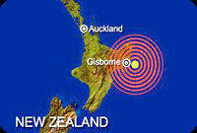
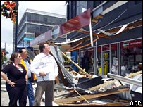

Nadine – got your e-mail about the 6.8 earthquake that rocked Gisborne. It also featured on the local TV news as well as the news on the local Australian TV channel. It was the biggest earthquake in NZ for 20 years. There were no direst fatalities, though one elderly woman died of a hear attack, and many people headed for the hills in case of a tsunami, which did not eventuate. However, this ‘quake did not compare with the 7.8 Napier earthquake in 1931 which flattened the city and raised the harbour right out of the water. At that time, Nana lived in Wairoa, halfway between Napier and Gisborne, which was also severely hit.

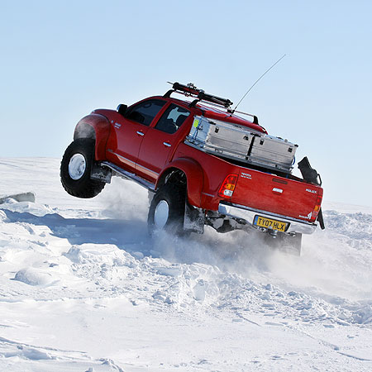
Watched a “Top Gear” show the other night. This was a special show, which involved driving the first truck/car (a Toyota Hilux, modified for the extreme conditions) to the North Pole for the first time. Two of the three presenters were in the track and they were racing against the third member who was part of a dog sled team. The truck won! In the truck they had a GPS system and I was puzzled why it did not show a latitude of 90⁰ North, which would indicate the North Pole. Checked on the Internet and found that it was the magnetic North Pole which is several hundred kilometres south of the true/geographical pole.

South Korea has elected a new president, a ‘conservative’ thus ending 10 years of ‘liberal’ rule. There is still a shadow over the election as the winner is accused of corruption while we was CEO of Hyundai and though not found guilty in a previous trial, may have to face another trial.
Went for a run yesterday. Again it was difficult! I think I might have found a reason – I am too heavy! I weighed myself of Friday and found that I was nearly 170 lbs! which is about my maximum weight. In the running season, I usually lose a bit of weight. Carrying the extra pounds may be the reason.
Got a Christmas letter from Bob and Janice. In it, they said how they very much enjoyed attending the wedding.
That’s about it for now.

Cheers
PS: Leonie:
Pass this message on to Tom’s brother. He mentioned to me that after the holiday next year, they are thinking of going to Egypt. I was to get his e-mail address and pass on the information directly but never got it.
1. The first website relates to the trip I did.
http://www.gobusegypt.com/
If they did this one. they should select the ‘tour’ rather than individual bus passes as the buses for individual travellers are only organised on an ad-hoc basis at each place and do not run a regular circuit (which is the impression given on the website) as the tour buses do.
2. This website is for slightly more up-market, uses slightly better hotels and is closer to the typical tour one would expect:
http://www.onthegotours.com/Egypt-Tours-with-On-the-Go-Tours
However, for younger people and the less formal tourist and for more fun, choose option 1
They might also be interested in reading the letters I sent you of my holiday in Egypt. If you saved them, pass copies on. If not, and if they would like them, let me know and I can send the files as I have them all saved.

